
ECONOMICS

Unit 3, Outcome 2
School-Assessed Coursework (SAC) 2
Structured Questions: ‘Domestic Macroeconomic goals’

STUDENT NAME: ______________________________________________
READING TIME: 5 minutes
WRITING TIME: 60 minutes
QUESTION AND ANSWER BOOK
Structure of book
Section | Number of questions | Number of questions to be answered | Number of marks
A | 10 | 10 | 10
B | 3 | 3 | 30
Total |  |  | 40

Conditions and restrictions
• Students are permitted to bring into the room for this task: pens, pencils, highlighters,
erasers, sharpeners and rulers and a calculator.
• Students are NOT permitted to bring into the room for this task: blank sheets of paper
and/or white out liquid/tape.

Materials supplied
• Question and answer book of 17 pages
Instructions
• Print your name in the space provided on the top of the front page.
• All written responses must be in English.

Students are NOT permitted to bring mobile phones and/or any other unauthorised electronic communication devices into the room for this task
Section A: Multiple Choice Questions
Instructions for section A
Answer all questions in pencil on the answer sheet provided for multiple choice questions.
Choose the response that is correct or the best answers the question.
A correct answer scores 1, an incorrect answer scores 0.
Marks will not be deducted for incorrect answers.
No marks will be given if more than one answer is completed for any question.

Question 1
Which of the following would most likely decrease as a result of an upturn in the business (economic) cycle?
A. the rate of inflation
B. the level of economic activity
C. the level of imports
D. the rate of unemployment

Question 2
A decrease in business productivity will have which of the following effects on the economy?
A. An increase in general prices, increase in real GDP and a decrease in unemployment
B. A decrease in general prices, increase in real GDP and a decrease in unemployment
C. An increase in general prices, a decrease in real GDP and an increase in unemployment
D. An decrease in general prices, a decrease in real GDP and an increase in unemployment

Question 3
Consider the following related to the labour market of a hypothetical economy.
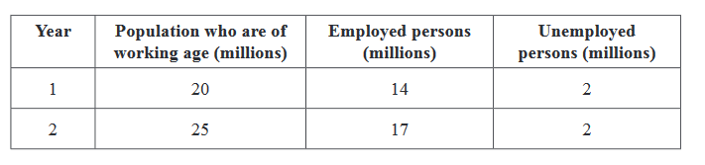
In comparing Year 2 to Year 1, which one of the following statements is true?

A. Year 2 has a lower participation rate and a lower unemployment rate.
B. Year 2 has a lower participation rate and a higher unemployment rate.
C. Year 2 has a higher participation rate and a lower unemployment rate.
D. Year 2 has a higher participation rate and a higher unemployment rate.

Question 4
Net exports in Australia is most likely to be increased by
A. a decrease in general prices (inflation)
B. an increase in domestic interest rates
C. a increase in the exchange rate
D. a fall in confidence in overseas markets

Question 5
Which of the following would be a negative consequence associated with high inflation?
A. Improvements in material living standards
B. Resource misallocation (this phrasing not in study design anymore)
C. Higher levels of household savings leading to higher household savings ratio
D. Higher levels of international competitiveness in Asian countries

Question 6
Which of the following is correct about the circular flow of income?
A. Increases in household consumption leads to higher leakages and a fall in real GDP growth.
B. A fall in government G2 expenditure on roads and hospitals will lead to higher injections and lower real GDP growth
C. A increase in the exchange rate may lead to improve international competitveness, higher injections and real GDP growth
D. A decrease in government income tax should lead to higher household consumption, higher injections and higher real GDP growth

Question 7
An increase in consumer confidence should have which effect on the domestic economy in Australia?
A. Aggregate Demand curve should shift to the right, general prices should rise and real GDP growth should rise
B. Aggregate Demand curve should shift left, general prices should fall and real GDP growth should fall.
C. Aggregate Demand curve should shift right, general prices should fall and real GDP growth should rise
D. Aggregate Demand curve should shift left, general prices should fall, and real GDP growth should fall

Question 8
Which of the following components of Aggregate Demand fluctuates the most?
A. Consumption
B. Investment
C. Net Exports
D. Government Expenditure

Question 9
The true extent of unemployment in Australia may be greater than indicated by the measure of the unemployment rate provided by the Australian Bureau of Statistics (ABS) because:
A. Only includes cyclical unemployment
B. Does not include those who are seeking part-time work.
C. does not include the unemployment of young people aged below twenty-one years.
D. does not include those who may have been discouraged from actively seeking work.

Question 10
Consider the following data for Country B.
 | 2015 | 2016 | 2017 | 2018
Consumer Price Index (CPI) | 100 | 103 | 105 | 104

Based on the information above, which one of the following statements is not true?
A. The country experienced deflation in 2018.
B. The country experienced deflation in 2017 and 2018.
C. Over the four-year period, the general level of prices rose.
D. The inflation rate in 2016 was higher than it was in 2017.

Section B – Short Answer questions (30 marks)

Inflation rate 2020 – present
7.8
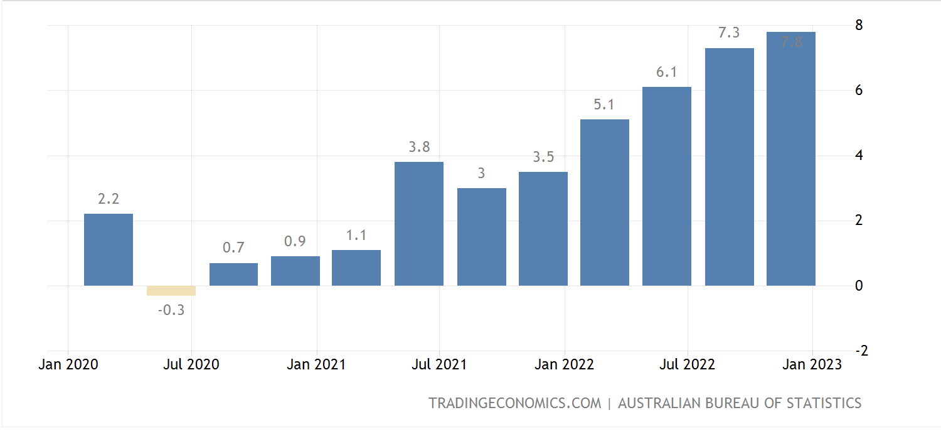

Question 1 (8 marks)
a. Describe the trend inflation rate since January 2021
2 marks
I mark for overall trend
1 mark for accurate reference to data from Jan 2021 (not 2020)

Sample answer
Since January 2021 there has been an upward trend in the inflation rate. This trend is clear given the inflation rate was 1.1% in January 2021 and is currently 7.8% in March 2023.

b. Describe one AD or one AS factor that has contributed to the trend in the inflation rate since 2021.
2 marks
1 mark accurate description of factor
1 mark for accurate description of how it has led to inflation

Sample answer 1:
One aggregate demand factor that has contributed to the trend in the inflation rate since 2021 is the exchange rate, which is the value of the Australian dollar ($AUD) against another currency. Over the last two years there have been a depreciation of the Australian dollar against the US dollar. This has made Australian exports cheaper to foreign conumsers, increasing the demand for exports. This also has increased the price that households pay for imports, decreasing expenditure on imports. Overall this increases net exports (x-m) and increases the level of aggregate demand in the economy. As the Australian economy is approaching its productive capacity, this increase in AD has put upward pressure on demand-pull inflation.
Sample answer 2:

One aggregate supply factor that has led to the increase in inflation over the last two years has been climatic conditions, such as the floods in Eastern Australia during 2022. These floods decreased the quality and quantity of factors of production (especially land resources) and decreased the productive capacity of the Australian economy. This led to capacity constraints and shortages in product and factors markets, putting upward pressure on the price level. Furthermore, the rising prises of inputs of in turn increased costs of production for firms, which was then passed on to households in the form of higher prices, increasing cost inflation in the economy since January 2021.

c. Identify and explain two consequences of high inflation.
4 marks
2 marks for identifying and fully explaining one consequence of high inflation. 1 mark for incomplete explanation.
2 marks for identifying and fully explaining second consequence of high inflation. 1 mark for incomplete explanation.
Consequences listed in study design: erosion of purchasing power, development of a wage-price spiral, distortion of spending and investment decisions, lower returns on investment, loss of international competitiveness.
Sample answer:
One consequence of high inflation in the economy is an erosion of purchasing power. Inflation means that households have a lower ability to consume goods because for a given level of income, they are unable to purchase as many goods due to the higher average price level. This is especially detrimental to households that are on low and fixed incomes.
A second consequence of high inflation is the development of the wage-price spiral. This is when higher inflation leads to workers requesting higher wages. Higher wage growth then increases the costs of production for firms in the economy, which they will pass on to consumers- leading to higher levels of cost push inflation in the economy. Higher inflation leads to workers again asking for higher wages, turning into a self-reinforcing cycle.

Question 2 (13 marks)
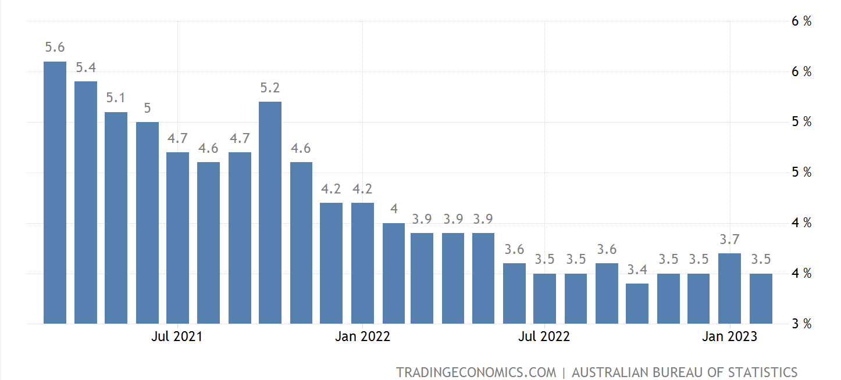

a. Evaluate the extent to which the economy has achieved the domestic macroeconomic goal of full employment over the past two years and discuss the effect of this on living standards.
6 marks
1 mark for showing understanding of the goal of full employment
1 mark for accurately referring to data in their answer
2 marks analysis of extent which the economy achieved the goal (to a large extent, moderate, small or to no extent). 1 mark for limited analysis.
1 mark for explanation on how the achievement or non-achievement of goal has had a positive impact on material or non-material living standards
1 mark for explanation of how the achievement or non-achievement of goal has had a negative impact on material or non-material living standards.
Note: for a 6 marker like this it will be somewhat globally marked, and there is likely a few different ways to answer it to achieve full marks.

Sample answer: Full employment is the level of unemployment that exists when the government’s economic growth objective has been achieved, and cyclical unemployment does not exist in the economy. It is the lowest unemployment rate possible without triggering inflation. This is also called the NAIRU, and is approximated to be between 4-4.5%
The Australian economy has, to a small extent, achieved the goal of full employment over the last two years. In 2021, while the unemployment rate was decreasing, the unemployment rate was still above the NAIRU for the entire year- as high as 6.4% in January 2021. In 2022, the unemployment rate fell to within the target range of 4-4.5% at the start of the year, but then fell below 4% for the majority of the year, which is outside the goal. This also coincided with a higher level of wage growth in and inflationary pressures in the Australian economy.
The impact on living standards would be mixed. Higher levels of employment and wage growth over this period would increase households’ access to goods and services, and therefore increase material living standards, ceteris paribus. That said, higher levels of inflation of up to 7.8% decreased the purchasing power of households during this period too, which would have decreased material living standards in the economy.

b. Outline the impact that an increase in the participation rate will have on the unemployment rate in the short run.
2 marks
1 mark for showing understanding of the participation rate and unemployment rate

1 mark for accurate explanation of how an increase in the participation rate would increase the unemployment rate in the short term.

Sample answer:

The participation rate is the percentage total of the ‘working age’ population (over 15) that is a member of the labour force. An increase in the participation rate indicated that there has been an increase in the number of people that are now willing and able to search for employment. This will increase the number of unemployed people in the economy, which will in turn increase the unemployment rate in Australia, which is the number of unemployed people divided by the labour force x100.

c. Explain the relationship between structural unemployment and long-term unemployment.
2 marks
1 mark for showing understanding of structural unemployment and long-term unemployment
1 mark for explaining the relationship between structural unemployment and long-term unemployment, and how structural unemployment is often the cause of long-term unemployment.
Sample answer:
Structural unemployment refers to a mismatch between the jobs available and the skill levels of the unemployed, while long-term unemployed means being unemployed for over 12 months.
There is a strong connection between structural unemployment and long term unemployment because structural unemployment is hard to correct. Structural unemployment can occur due to long-term changes in the economy which make certain jobs not exist anymore due technological advances, outsourcing of labour, geographical location and changing patterns of demand, This makes it difficult for some that are structurally unemployed to find new employment opportunities, leading to an increase in long term unemployment.

d. Explain one AD factor that could have had a positive impact on the trend in the unemployment rate over the last two years
3 marks
1 mark for identifying that there has been a decreasing trend in the unemployment rate
2 marks for accurate explanation of an AD factor which would decrease cyclical unemployment and lead to a decrease in the unemployment rate. 1 mark for limited explanation (e.g. not linking through AD, or not fully explaining how it would decrease unemployment)
Sample answer:
One aggregate demand (AD) factor that could have positively influenced the unemployment rate over the last two years is an increase in consumer confidence. Consumer confidence is the level of optimism that households have about their future financial situation. When there is an increase in consumer confidence it means that households will have a higher propensity to consume, and lower propensity to save their income. This is increase private consumption expenditure in the economy (C), increase the level of AD. Greater levels of total spending in the economy will increase the derived demand for labour resources, decreasing cyclical unemployment and leading to the decreasing trend in the unemployment rate.
Note: because it said a factor that ‘could’ have influenced AD and unemployment, students can use any AD factor, it does not have to be from real life data.

Question 3 (9 marks)
a. Describe two consequences of not achieving the goal of strong and sustainable economic growth and outline its effect on living standards.
5 marks
1 mark for showing understanding of the goal of strong and sustainable economic growth
1 mark x2 for accurate explanation of consequence of not achieving goal: inflationary pressures, environmental pressures or external pressures if growth is too high, unemployment if growth is too low
1 mark x2 for linking each consequence to material or non-material living standards.
Sample answer:
The government’s goal for strong and sustainable economic growth is to achieve the highest growth rate possible, consistent with strong employment growth, but without running into unacceptable inflationary, external or environmental pressures. This is a target of 3-3.5% real GDP per year.
One consequence of not achieving the goal of strong and sustainable growth is inflationary pressures. If real GDP is above the target of 3-3.5%, this can lead to the Australian economy utilising a greater number of scarce resources for production and then facing ‘capacity constraints’ as the economy approaches its productive capacity. This can put upward pressure on the average price level, leading to inflationary pressures in the economy, which will decrease the purchasing power of households. This decrease in purchasing power of household will decrease their access to goods and services, reducing material living standards.
A second consequence of economic growth being too high is environmental pressures. When real GDP reaches growth above 3-3.5% per year, it will require a greater number of land resources. This higher level of resources use in the economy runs the risk of depleting these natural resources and causing environmental degradation. Decreasing environmental quality reduces the wellbeing and quality of life people in the economy, decreasing non-material living standards.
b. Identify and explain one aggregate supply factor that has had a positive impact on the goal of strong and sustainable growth over the last two years, ceteris paribus.
4 marks
1 mark for accurate identification of real life AS factor that has had a positive influence on AS and economic growth
2 marks for explanation of how trend in the AS factor would increase non-inflationary economic growth in the economy, 1 mark for limited explanation
1 mark for link back to the goal
Sample answer:
One aggregate supply factor that has had a positive impact on the goal of strong and sustainable growth over the last two years has been lower costs of production due to falling crude oil prices. Oil is one of the most commonly used factors of production in the Australian economy, and over the last two year the price per barrel has fallen from around $100 a barrel to around $70 a barrel in 2023. This lowers the costs of production for firms, increasing their ability to produce goods and services, increasing productive capacity and AS in the Australian economy. An increase in productive capacity allows for an increase in non-inflationary growth in the economy, therefore having a positive impact on the goal of strong and sustainable economic growth, which is to achieve the highest growth rate possible, consistent with strong employment growth, but without running into unacceptable inflationary, external or environmental pressures.

